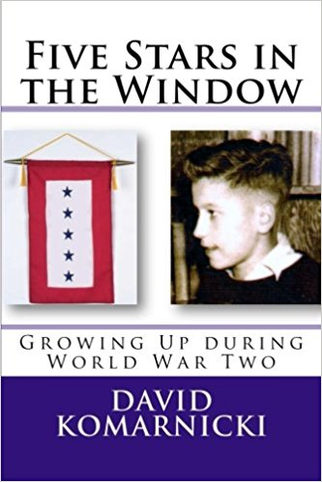

Synopsis:
The city of Chester, Pennsylvania, is pulsing with activity during World War Two, grinding out ships, planes, and helicopters at record rates to fuel the fight against Hitler and Hirohito. Its winding streets are a patchwork quilt of ethnic neighborhoods, and families display stars in their windows to show they have sons or fathers off serving their country.
There are five stars in the window of young David’s house, representing four of his seven brothers and the husband of one of his two sisters. While he prays for their safe return, David peddles newspapers to the shift-workers at the war plants, dodges the local traffic cop who wants to shut down his shoeshine business, hookies school to hear Louis Armstrong in Philly, and does his best to negotiate adolescence on the home front.

